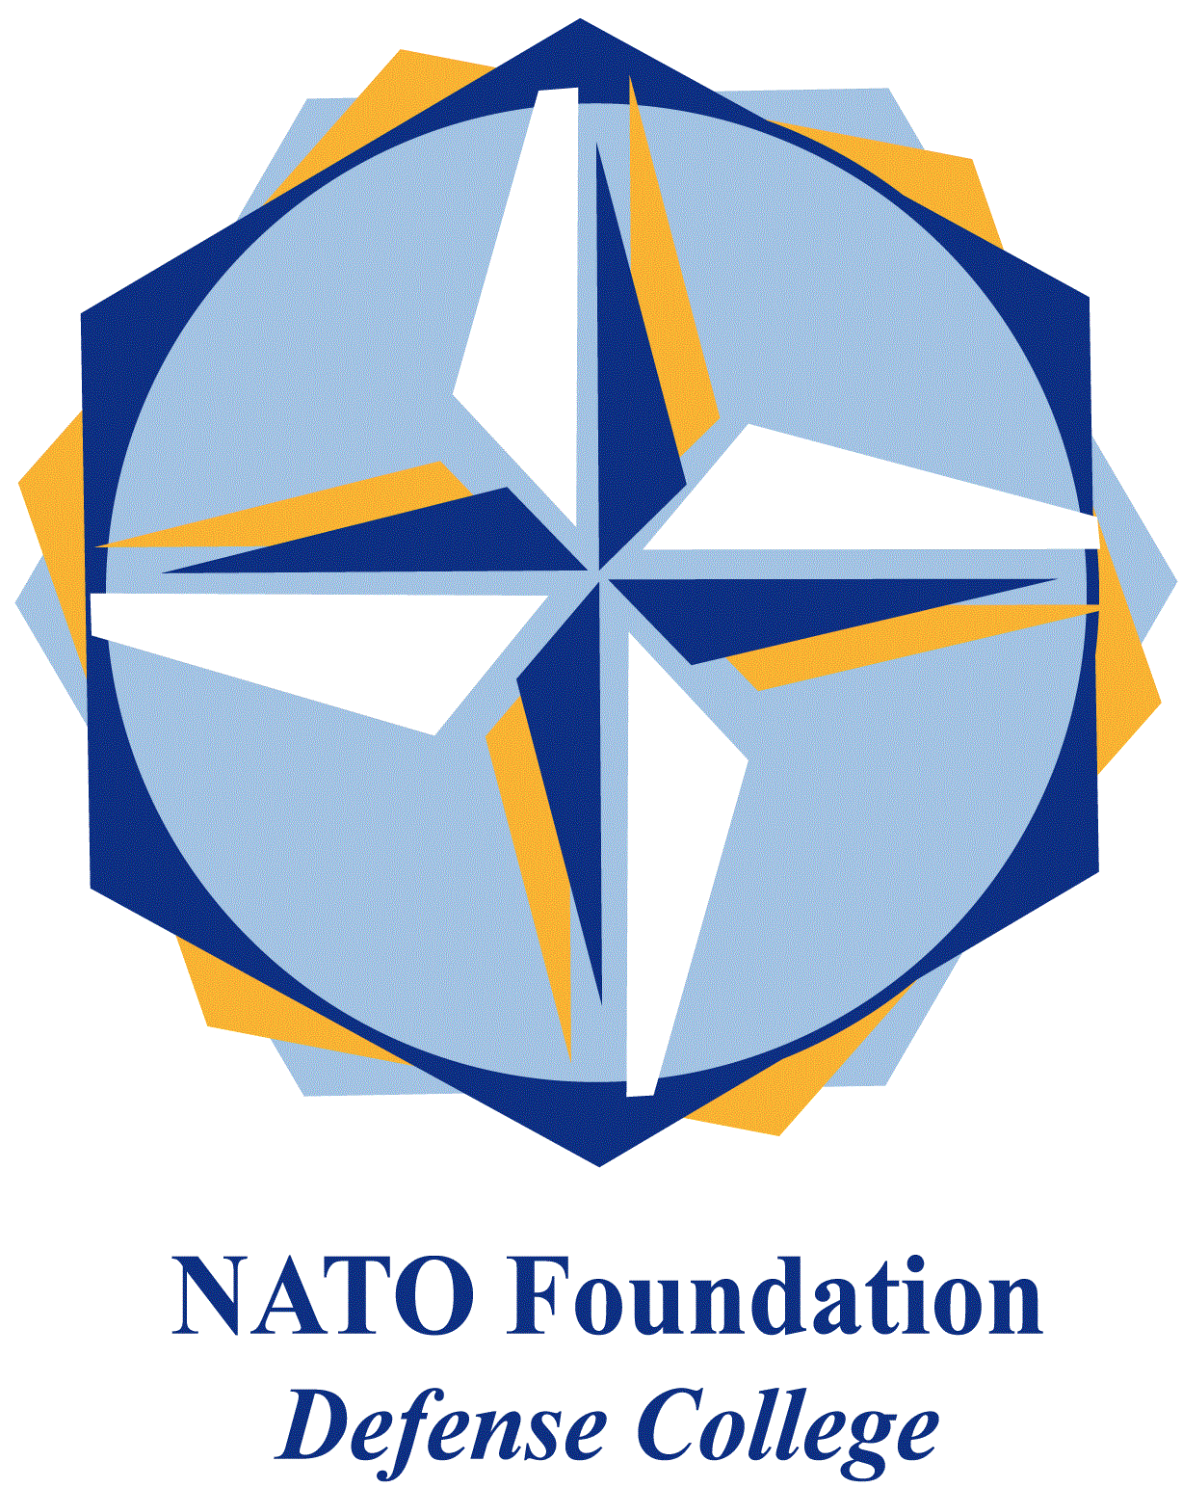
NATO DEFENSE COLLEGE FOUNDATION
STRATEGIC TRENDS
November 2015
BALKANS
Skopje: Euro-fatigue ahead
On the 11-13th November the government organized in Skopje the First Central European Initiative Diplomatic Forum of the Diplomatic Academy (MFA). The Forum, entitled “Macro and Micro strategies for Development: Strengthening Diplomatic Capacities in the CEI Region”, gave the possibility to debate on the main current themes of the Macedonian diplomacy.
The Forum allowed the Macedonian government to present itself as a reliable and solid partner of the European Union and the Balkan countries. Inevitably, the debate of the Forum frequently touched upon the topic of EU enlargement both at micro and macro political and economic level.
The Former Yugoslav Republic of Macedonia, that didn’t yet solve its dispute with Greece on the name, applied to join the European Union for the first time in 2004. The following year FYROM and EU signed the Stabilisation and Association Agreement defining the general diplomatic framework for two parties. Macedonia (FYROM) obtained the accession to the status of “candidate country”.
Since then, Macedonian ambitions stalled for a long time. The stalemate ended only in 2012, when a High-Level Accession Dialogue started between the European Commission and the government of the Former Yugoslav Republic of Macedonia. Together with the typical difficulties of the enlargement policy, a series of outstanding matters still hamper FYROM’s accession. According to the European Commission, rule of law, public administration system, level of freedom of expression, electoral system and market economy are inadequate.
Furthermore, a few of crucial political issues remain on the table and affect the debate. The most delicate ones are: the need of internal reform and liberalizations, the unsolved dispute with Greece, and the festering conflict with part of the Albanian minority in the west of the country. Regarding the last point, a few months ago the Strategic Trends analysed the latest clashes in Kumanovo.
In conclusion, the accession to the European Union remains a crucial objective of Macedonia’s foreign policy, but in the last years this goal was put in doubt. On one hand fulfilling the recently narrowed European criteria requires a high political commitment; on the other hand EU’s attractiveness and influence are slowly vanishing. Macedonia is the only State in western Balkans that in the 90s did not experience a destructive war, and in more than one circumstance it represented a factor of stability in the region. The enlargements that included Romania and Bulgaria in 2007 and Croatia in 2013 disappointed Skopje, notwithstanding the fact that those countries are not encouraging a further enlargement.
According to the welcome speech given by the President of the Republic Gjorge Ivanov on the 11th of November, Macedonia is strongly committed in continuing the road to European integration. But also if Macedonia did not abandon the proposal of joining the European Union, a sense of political fatigue frequently emerged during the seminar. Serious domestic and international problems persist, but the European Union has the task to collaborate with his neighbours and to keep alive the proposal of a future enlargement, before fatigue induces this country to look somewhere else (e.g. Russia).

